Group Project 3
Due Sunday 11/24/2019 by 11:59 PM
No delay is accepted
For each day late submission 2 points penalty is incurred.
Post your answer on Project 3 on the blackboard.
If you have any question please email me at mbadii@pace.edu

Eric Chen, Abhinav Bhatt, Yixuan Ma, Yerson Nieto
Do not delete anything from this file. Just write your answer under the word: Answer.
Write a C program using MPI to calculate the area of a triangle. The process with the rank: 0 sends two floating point numbers for the base and height to all other processes. Each of these processes calculate the area of the triangle and display.
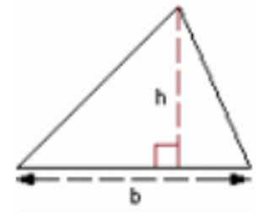
area = b * h/2
The following is just a sample dialog. Your program must work for any floating point number.
Enter two floating point numbers for the base and the height of a triangle.
10 12
Height = 12.00, base = 10.00
The area of the triangle is: 60.00
Height = 12.00, base = 10.00
The area of the triangle is: 60.00
Height = 12.00, base = 10.00
The area of the triangle is: 60.00
Height = 12.00, base = 10.00
The area of the triangle is: 60.00
Answer:

#include <stdio.h>
#include <string.h>
#include <mpi.h>
#define BASE 0
#define HEIGHT 1
int main()
{
float base, height, i;
int comm_sz, my_rank;
MPI_Init(NULL, NULL);
MPI_Comm_size(MPI_COMM_WORLD, &comm_sz);
MPI_Comm_rank(MPI_COMM_WORLD, &my_rank);
if (my_rank == 0)
{
printf("Enter two floating point numbers for the base and the height of a triangle.\n");
scanf("%f%f", &base, &height);
for(i = 1; i < comm_sz; i++)
{
MPI_Send(&base, 1, MPI_FLOAT, i, BASE, MPI_COMM_WORLD);
MPI_Send(&height, 1, MPI_FLOAT, i, HEIGHT, MPI_COMM_WORLD);
}
}
else
{
MPI_Recv(&height, 1, MPI_FLOAT, 0, HEIGHT, MPI_COMM_WORLD, MPI_STATUS_IGNORE);
MPI_Recv(&base, 1, MPI_FLOAT, 0, BASE, MPI_COMM_WORLD, MPI_STATUS_IGNORE);
printf("Height = %.2f, Base = %.2f\n", height, base);
printf("The area of the triangle is: %.2f\n", (base) * (height/2));
}
MPI_Finalize();
}

